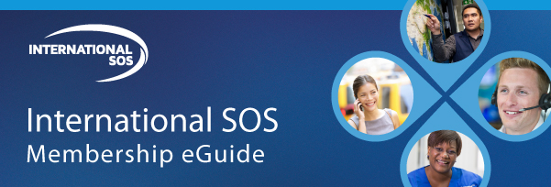

Someone to Count On

At [insert organization name], we partner with International SOS, the leading global medical and security assistance company, to oversee the health, safety and well-being of our employees when projects, meetings or other work takes them outside their home country. International SOS is pleased to introduce a new tool to help you easily access online advice and better understand when to call one of their 27 global assistance centers that operate around the clock with logistical experts available to answer any of your concerns. No issue or question is too small, especially when you’re away from home and familiar surroundings.

This interactive Membership eGuide tells you how to easily prepare for an overseas trip or assignment, as well as:

- How and when to seek assistance;
- Find medical advice about a destination online;
- Information on how to use the International SOS Assistance App.

International SOS is our trusted partner when you travel or live away from home, so please take a few minutes to review this tool to help you stay healthy, safe and secure.

